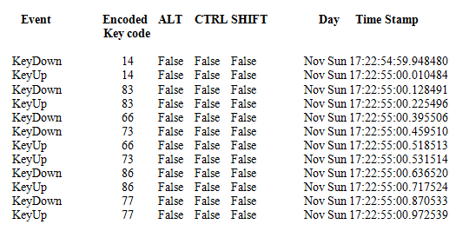**Figure 1**

X

Y

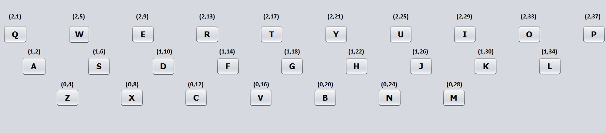

**Figure 2**

**Collected continuous keystroke data from users (registered or not registered)**

**For new enrolled users map each consecutive keystroke transition in the string to its radius, angle and direction of the movement of the hands**

**Find equivalent transitions from the continuous data for each consecutive pair of keystrokes typed in the string**

**Check if there are enough transitions available for preparation of the user model.**

**Calculate Features and form feature vectors**

**Prepare User model using supervised learning approach**

**System is ready for verifying the identity of the user**

**Figure 3**

**Figure 4**